

**Project Phase 3**

**GROUP No.49**

**PROJECT: Static E-commerce website**

|  |  |  |
| --- | --- | --- |
| Group Members | | |
| NAME | ID No | Remarks |
| Azhar Naeem | 49284 |  |
| Ahmed Hassan | 49384 |  |
| Arif Hussain | 49386 |  |

Submitted To: Dr.Mansoor Ebrahim/Ms.Ghazala Shafi

Assignment # 3

**Phase3: Requirement Analysis**

1. Define all the functional and non-functional requirements of your project.

**REQUIREMENT ANALYSIS: -**

This project aims to develop an online shopping for customers with the goal so that it is very easy to shop your loved things from an extensive number of online shopping sites available on the web. With the help of this you can carry out an online shopping from your home. Here is no compelling reason to go to the crowed stores or shopping centres during festival seasons. You simply require a PC or a laptop or a mobile phone and one important payment sending option to shop online. To get to this online shopping system all the customers will need to have an email and password to login and proceed your shopping. The login credentials for an online shopping system are under high security and nobody will have the capacity to crack it easily. Upon successful login the customers can purchase a wide range of things such as mobiles, books, apparel, jewellery, infant care, gifts, tools, etc. can be dispatched using online shopping system. Not just these, you can also purchase from outside nations by few clicks on your mouse. And of course, you will get your requested ordered items at your door step. It is simple. You will pick your favourite items from variety of online shopping sites looking at cost and quality. No need to go physical shops with this you will have more time to spend with your family. It Just need a computer and a payment making options like net banking, credit card, debit card or PayPal. Almost a wide range of things can be brought through online shopping system. You can purchase goods from foreign places from your bedroom and you will get your goods at your home. It is extremely secure. Customer service is accessible.

**REQUIREMENT SPECIFICATION: -**

**FUNCTIONAL REQUIREMENTS**: -

Registration: - A new user will have to register in the system by providing essential details in order to view the products in the system. The admin must accept a new user by unblocking him.

Login: - A user must login with his user name and password to the system after registration.

Add Products The shopping cart project contains different kind of products. The products can be classified into different categories by name. Admin can add new products into the existing system with all its details including an image.

View Products: - User can view the list of products based on their names after successful login. A detailed description of a particular product with product name, products details, product image, price can be viewed by users.

Delete Products: - Content Manager can delete the products based on the stock of that particular product.

Search products: -Content Manager will have a list view of all the existing products. He can also search for a particular product by name.

View Order: - User can view the Orders which is generated by the users. He can verify the details of the purchase.

Delete Order: - User can delete order from the orders list If they do not want to but it.

Add to cart: - The user can add the desired product into his cart by clicking add to cart option on the product. He can view his cart by clicking on the cart button. All products added by cart can be viewed.

**NON-FUNCTIONAL REQUIREMENTS**: -

i. EFFICIENCY REQUIREMENT: - When an online shopping cart Web application implemented customer can purchase product in an efficient manner.

ii. RELIABILITY REQUIREMENT: - The system should provide a reliable environment to both customers and owner. All orders should be reaching at the admin without any errors.

iii. USABILITY REQUIREMENT: - The Web application is designed for user friendly environment and ease of use.

iv. IMPLEMENTATION REQUIREMENT: - Implementation of the system using CSS , html and Gatsby in front end with just as back end and it will be used for CMS connectivity. And the database part is developed by GraphQl. Responsive web designing is used for making the website compatible for any type of screen.

v. DELIVERY REQUIREMENT: - The whole system is expected to be delivered in ­­___ months of time with a weekly evaluation by the project guide.

**SOFTWARE AND HARDWARE REQUIREMENTS**: -

Hardware Requirements: - ➢ Operating System: - Windows 7 and above ➢ Processor: - Intel i3 or above ➢ Installed Memory (RAM): - Minimum 1 GB ➢ System Type: - 32-bit or 64-bit Operating System Software Requirements: - ➢ Front End: - HTML, CSS, JS, Bootstrap ➢ Back End: - Contentful Api.

1. Develop complete use case diagram and define use cases with narratives.

Registered Customer

Web Customer

Content manager

New Customer

|  |  |  |
| --- | --- | --- |
| **Use Case Name:** | Register to Website | |
| **ID:** | UC-LHD-01 | |
| **Actors Involved:** | New Customer | |
| **Brief Description** | Actor enters the Information to register to the system. | |
| **Pre-Conditions** |  | |
| **Post-Conditions** |  | |
| **Normal Flow of Events:** | **Actor Action** | **System Response** |
| 1. Enter Information required. 2. Clicks the submit button. | 1. System displays the actor mail page on successful Register. 2. System displays error message on invalid login. |

New Customer

Registered Customer

Registered Customer

Use Case Narrative:

|  |  |  |
| --- | --- | --- |
| **Use Case Name:** | Login to Website | |
| **ID:** | UC-LHD-02 | |
| **Actors Involved:** | Registered Customer, Web Customer | |
| **Brief Description** | Actor enters the email address and password to login to the system. | |
| **Pre-Conditions** | Actor must be registered | |
| **Post-Conditions** |  | |
| **Normal Flow of Events:** | **Actor Action** | **System Response** |
| 1. Enter email address and password. 2. Clicks the submit button. | 1. System displays the actor mail page on successful login. 2. System displays error message on invalid login. |

|  |  |  |
| --- | --- | --- |
| **Use Case Name:** | Add/Update/Delete Product & Category | |
| **ID:** | UC-LHD-03 | |
| **Actors Involved:** | Content Manager | |
| **Brief Description** | Actor adds product and category to the system | |
| **Pre-Conditions** |  | |
| **Post-Conditions** |  | |
| **Normal Flow of Events:** | **Actor Action** | **System Response** |
| 1. Add Product/Category. | 1. Display Product / Category on webpage. 2. Create dynamic page for each product. |

Content Manager

**Phase 4: Usability**

1. Design the user interface using paper prototype and wireframes for your project. Follow all the rules that are discussed in the lecture.

**HOME PAGE:**

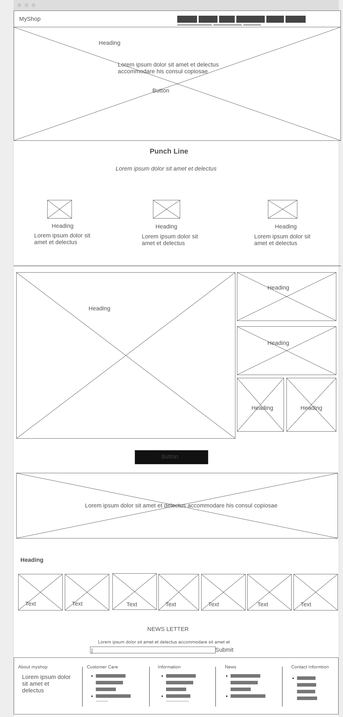

**ABOUT PAGE:**

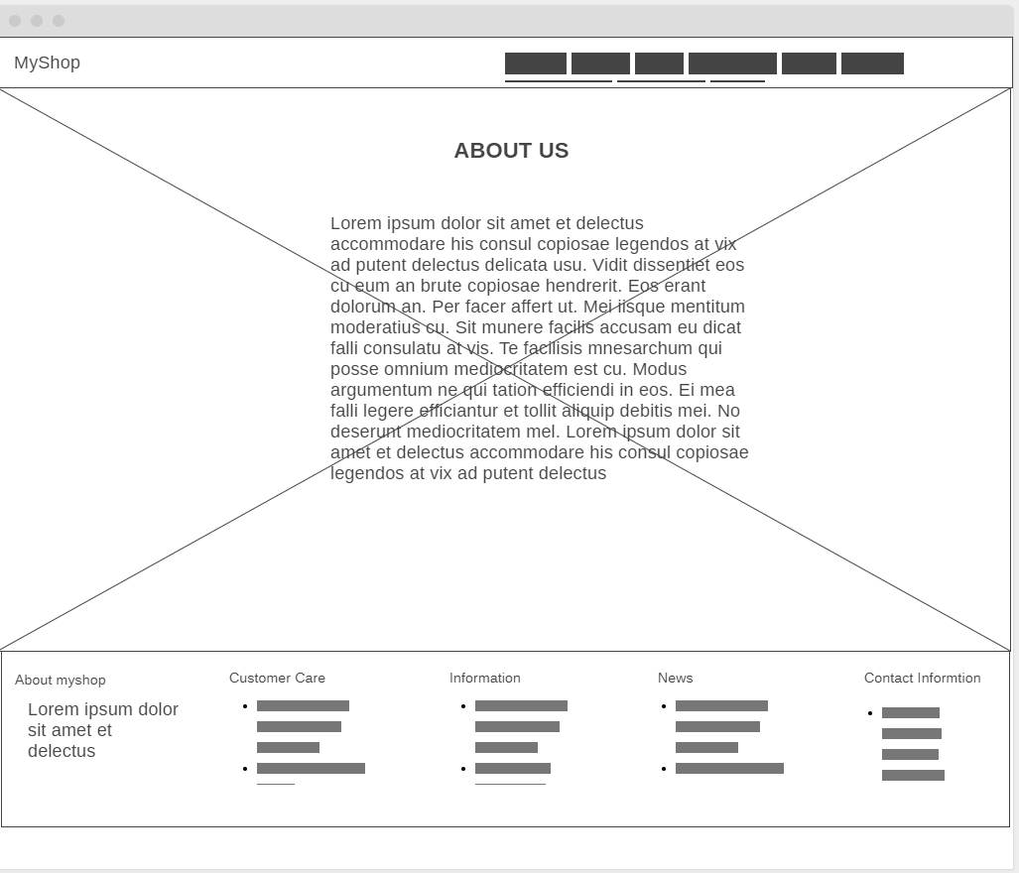

**CONTACT PAGE:**

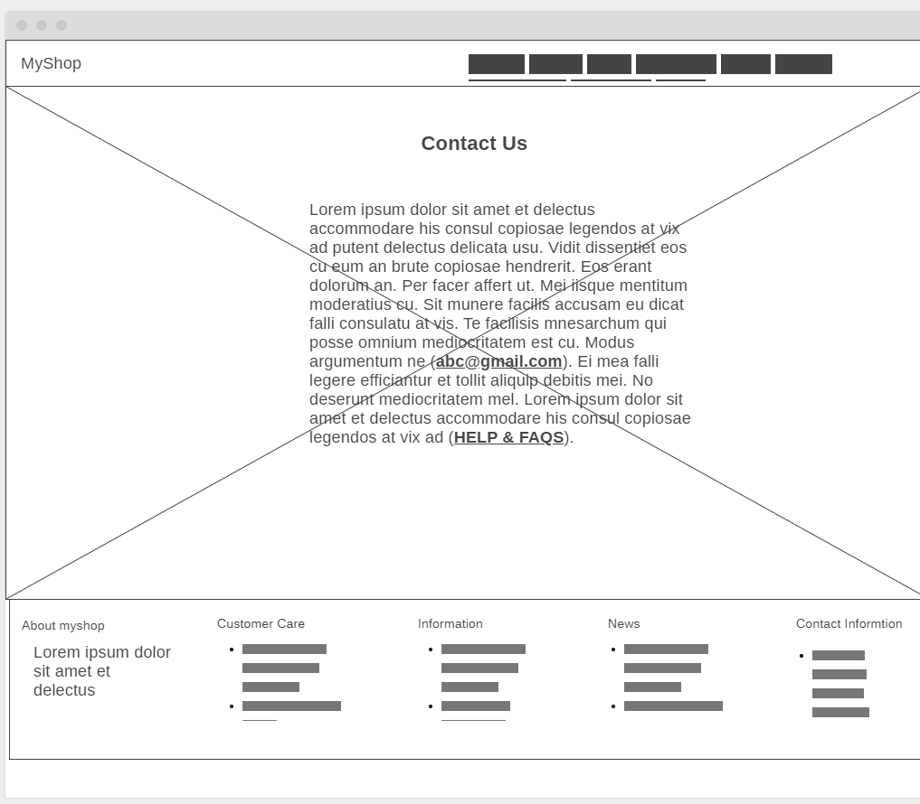

**SIGNUP PAGE:**

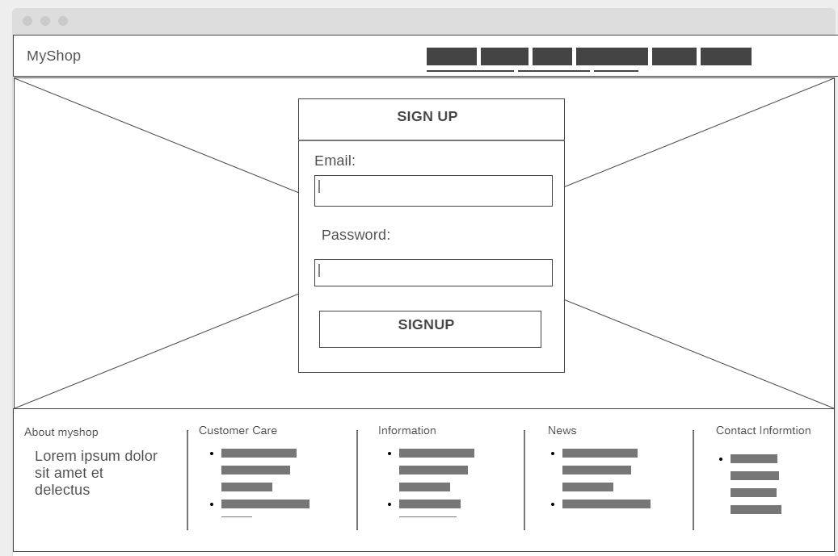

**PRODUCT PAGE:**

